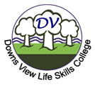
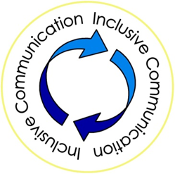
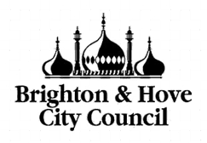

DVLSC Overall score: Excellent

DVLSC registered in 2021-2022 to be part of B&H Inclusive Communication Charter. This is a benchmark for communication support in adult learning disability services.

In 2014 the Royal College of Speech and Language Therapists developed the 5 Good Communication standards to ensure that services use an inclusive communication approach.

By being part of the charter, DVLSC agreed to implement all the standards. DVLSC was part of an audit for each individual strand. This included speaking with professionals, looking for evidences and observing lessons.

In August 2022 DVLSC was granted with the highest overall score of "excellent".

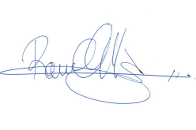
Communication is at the heart of our vision to support learners in their adulthood individually. We are already working to improve how better we can use an inclusive communication approach and support their communication.

Raul Ortiz
Head of site DVLSC
Designated Safeguarding Lead

