The recovery curriculum
DVLSC

What is recovery? The Recovery from Covid19 team, led by Professor Duncan Shaw from the University of Manchester (2020 defined recovery as “the process of rebuilding, restoring and rehabilitating society following an emergency.” Recovery is a gradual process that aims to generate positive outcomes. Achieving this “new normality” is a complex social and developmental process, rather than just a remedial process. Furthermore, recovery should be done “with” the community not “to” the community, and this will be reflected in our Recovery curriculum.
When learners return to college, they will benefit from a recovery curriculum strategy. For many learners, their daily outcomes in going to college will be to see teir friends and peers, their teaching staff and to feel a sense of community and belonging. It is highly difficult to estimate the impact of the loss of that social interaction, and we must not underestimate it.
Anxiety, trauma and bereavement are three significant dynamics that can appear as consequence from loss and this can impact markedly on the mental health of our learners as young adults. They are even more vulnerable at this time, and their mental health can be fragile. Additionally, they are witnessing many adults suffering from anxiety, including their so called “trusted adults” such as relatives, friends or professionals. In some cases, they may absorb this emotion to some extent.
This, added to a loss of freedom, routine and social interaction will have made academic learning feel inconsequential. The loss of routine and structure will be traumatic for some. Already there are increased reports of incidents of self-harm (Young Minds, 2020).
Within the college environment, we could summarize this in 5 losses: routine, structure, friendship, opportunity and freedom. And, as stated above, it can trigger an emergence emotionally of anxiety, trauma and bereavement in any child or young adult.
Our learners will need a holistic recovery, a strategy based on a recovery curriculum personalised to each individual’s needs. Some may need a longer and deeper lasting recovery period.
Teaching is a relationship-based profession that has been highlighted during the lockdown period. In our context, this has been clearly reflected in the response of the teaching profession, supporting learners through weekly phone calls, online learning, fortnightly sets of homework, newsletters, and video-call sessions.
Following the different elements stated above, Barry Carpenter and Matthew Carpenter (2020) suggested that the Recovery Curriculum is built on 5 levels as a systematic, relation-based approach to reigniting the flame of learning in each learner. They discussed five levels of recovery that we will have into account in our recovery curriculum:
Level 1: Relationships – We need to plan and include lessons expecting our learners not returning joyfully, and many of the relationships that were thriving, may need to be invested in and restored. Reach out to greet them, use the relationships we build to cushion the discomfort of returning.
Level 2: Community- We need to listen to what has happened in this time, understand the needs of our community and engage them in the transitioning of learning back into school.
Level 3: Transparent curriculum- We need to include the learners in the curriculum. We must show them how we are addressing the gaps in the loss of time in learning, consulting and co-constructing with our learners to heal this sense of loss.
Level 4: Metacognition- It is vital that we make the skills for learning in a school environment explicit to our students to reskill and rebuild their confidence as learners.
Level 5- Space- to be, to rediscover self, and to find their voice on learning in this issue. It is only natural that we all work at an incredible pace to make sure this group of learners are not disadvantaged against their peers, providing opportunity and exploration alongside the intensity of our expectations.
Additionally, promoting well-being will be one of our first priorities during this period. Following the guidance from UK government (2020), as a summary they state that to support the learners’ wellbeing we need to ensure that we:
- Set realistic expectations
- Maintain a sense of community with parents, careers and pupils.
- Maintain a sense of community with staff (this is reflects in our weekly or daily meetings, email / What’sApp chats, zoom training and others)
- Providing pastoral support
- Staying in contact
- Identifying pupils who need additional support (this applies to all DVLSC learners).

Following the reflections above, you can see below a set of initial strategies for September to follow at DVLSC, as well as resources:
- Daily PSHE short sessions linked with emotions, mental health and wellbeing.
- Daily exercise within group bubbles. To use an outside space when possible and walk around the college within the college.
- Focus on kindness- we would like to focus on Kindness as is the theme of this year’s Mental Health Awareness Week (May 2020). For example, reflecting on what acts of kindness others have done during the day.
- Books to share. Story telling lessons based on books regarding emotions, mental health, washing hands, social distancing, bereavement and coronavirus (as needed and as appropriate). Please see next section.
- Social Stores- as needed and as used previously. They can be individualised or for a group.
- Happiness boxes- As needed. Some learners have already their own box. You can find below a link to a step-by-step guide for welcoming learners back to college. It will enable learners to build their emotional resilience, and self-regulate their emotional wellbeing.
- Initially to hold video student councils on Tuesdays and Fridays for all. Learners to be in group bubbles in their own class as like the rest of the day. This will help to repair, build and strengthen relationships and to re-create a sense of belonging and community
- Initially to send a weekly newsletter.
- Daily feedback at the end of the day. Transparent curriculum, sense of cooperation, trust and relationships.
- Repetition of skills already achieved and latest areas of learning if needed or applicable. This will help to reconnect with their learning before the lockdown. It will be more likely that they will be more successful at college, and therefore, more engaged, confident and willing to return again to college. Metacognition.

Books to share
As we prepare to partially reopen college after closures due to Covid-19, well-being is going to be high on the agenda.
The list of books below is adult-like and focuses firstly on mental health and bereavement around coronavirus.
Secondly, you can see books focus on naming, identifying and managing emotions, washing hands and social distancing to be used as part of our recovery curriculum strategy. You can find a brief synopsis of each title and some questions to prompt discussion or activities.
- Coronavirus related books; when someone is ill/dies from coronavirus; good and bad days during lockdown; beating the virus.
- Naming, identifying and managing emotions; washing hands; social distancing

Coronavirus related books – To be used as needed
https://booksbeyondwords.co.uk/coping-with-coronavirus/#MH-resources

Let’s talk about…when someone is ill or dies from coronavirus
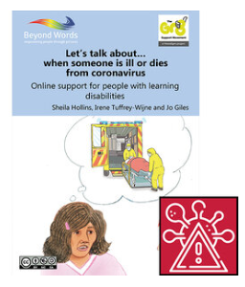
Online support for people with learning disabilities
Images and suggested questions to prompt discussion about the impact of coronavirus on people's lives, and especially the impact of people dying from coronavirus.

Good Days and Bad Days During Lockdown
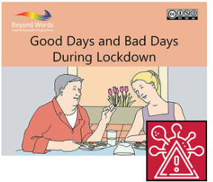
A wordless booklet with scenes from existing Beyond Words stories looking at what makes a ‘good day’ and what makes a ‘bad day’.
Scenes address social distancing, lockdown, mental health and daily routines.

Beating the Virus
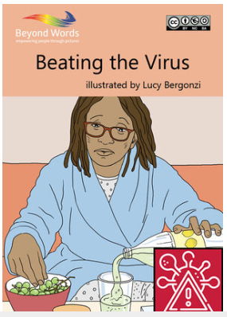
illustrated by Lucy Bergonzi
A short wordless story, that will help people to understand what to do if you have Coronavirus and how to keep yourself and those who you care about safe. The story also shows how to safely help others who may be self-isolating. Supplementary text at the end of the story gives information on where people can seek help if they are unwell and signposts to other useful resources.

Recovery curriculum- Books

Ruby’s Worry

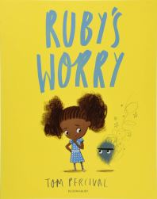
by Tom Percival
“Ruby loves being Ruby. Until, one day, she finds a worry. At first it’s not such a big worry, and that’s all right, but then it starts to grow. It gets bigger and bigger every day and it makes Ruby sad. How can Ruby get rid of it and feel like herself again?”
- Do you think Ruby’s worry will stay with her forever?
- What happens when Ruby ask the boy what is on his mind?
- How can you make your worry shrink?
- Would you like to share a worry you have had?
- Who can you talk to if you are feeling worried about something?

While We Can’t Hug

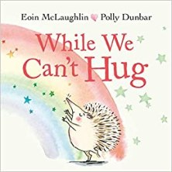
written by Eoin McLaughlin and illustrated by Polly Dunbar
“Hedgehog and Tortoise were the best of friends.
They wanted to give each other a great, big hug.
But they weren’t allowed to touch.
“Don’t worry,” said Owl. “There are lots of ways to show someone you love them.”
So the two friends wave to each other, blow kisses, sing songs, dance around and write letters. And even though they can’t hug and they can’t touch, they both know that they are loved”
- What do hedgehog and tortoise do, while they can’t hug?
- How can we show are friends and family we care while social distancing?
- Have you drawn any rainbow pictures?
- What picture would you like to draw?
- What could your friend do to make you smile, while socially distancing?

I Don’t Want to Wash My Hands
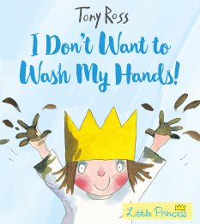
by Tony Ross
“The Little Princess loves getting her hands dirty. The trouble is . . . she hates washing them. Until she learns all about the nasties and the dirties and all the other horrible things that lurk and make you ill …”
- Do you think the maid had washed her hands?
- Why is it important to wash our hands?
- What steps do we need to follow when we are washing our hands?
- When do we need to was our hands?

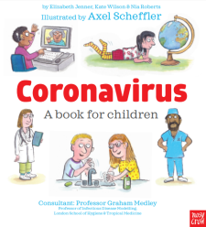
Coronavirus: a book for children
written by Elizabeth Jenner, Kate Wilson and Nia Roberts and illustrated by Axel Scheffler
Consultant: Professor Graham Medley
“There’s a new word you might have heard.
You might hear people talking about it or you might hear it on the news. This word is the reason that you’re not going to school. It is the reason you can’t go outside very often or visit your friends. It might be the reason why the grown-up or grown-ups who look after you are at home. The word is… Coronavirus”
Available to view here
https://nosycrowcoronavirus.s3-eu-west-1.amazonaws.com/Coronavirus_ABookForChildren.pdf
*The text refers to school closures so may need to adapt.
- What can you do if you are feeling worried about Coronavirus?
- Who can you ask if you have more questions?
- What can you do to help your adults, while we are at home for longer than usual?

You’re Safe With Me
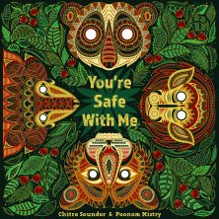
written by Chitra Soundar and illustrated by Poonam Mistry
“When the moon rises high and the stars twinkle, it is bedtime for the baby animals of the Indian forest. But tonight, when the skies turn dark and the night grows stormy, the little ones can’t sleep. SWISH-SWISH! CRACK-TRACK! FLASH-SNAP! goes the storm. Only Mama Elephant with her words of wisdom can reassure them, ‘You’re safe with me.'”
- What makes the animals feel frightened?
- Is there anything that makes you feel a little frightened?
- How does Mama Elephant make the animals feel better?
- What does she say to them?
- Who do you feel safe with?

The Worrysaurus

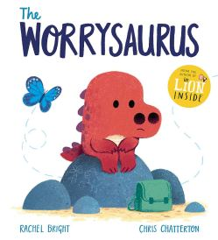
written by Rachel Bright and illustrated by Chris Chatterton
“It’s a beautiful day and Worrysaurus has planned a special picnic.
But it isn’t long before a small butterfly of worry starts fluttering in his tummy . . .
What if he hasn’t brought enough to eat?
What if he gets lost in the jungle?
What if he trips and falls?
What if it rains?!
Can Worrysaurus find a way to chase his fears away and have fun?”
- How does the Worrysaurus’ body feel when he is worried?
- How does your body feel?
- What makes you feel worried?
- What could you put in your tin to help chase your butterfly away?

The Colour Monster
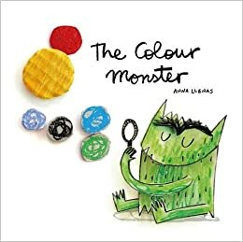
by Anna Llenas
“One day, Colour Monster wakes up feeling very confused. His emotions are all over the place; he feels angry, happy, calm, sad and scared all at once! To help him, a little girl shows him what each feeling means through colour. A gentle exploration of feelings for young and old alike.”
- What do you do when you’re happy/sad/angry/scared
- What can you do when you when you are feeling sad/angry/ scared
- ‘If you’re scared.. tell me why and we will walk through the forest together’ – who can you talk to if you are scared or worried? Who do you walk through the forest with?
- What do you think pink means?

The Jar of Happiness
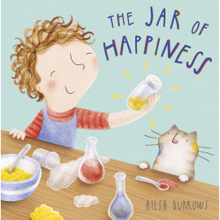
by Ailsa Burrows
“Is there a recipe for happiness? Meg certainly thinks so. She collects all the necessary ingredients in a jar, which she uses to cheer up her friends and family when they are feeling low. But what happens when her special jar mysteriously disappears? Will Meg feel sad forever more, or will she find other ways to be happy?”
- What would your kind of happiness taste like?
- What colour would it be?
- What would it smell like?
- What does Meg do to help Zoe when she is feeling ‘glum’?
- How do you think Meg feels when she can’t find her jar? How do you know?
- How do Zoe, Oma and Leo make Meg feel better?
- What makes you feel happy when you are feeling sad?

Anna Hibiscus’ Song
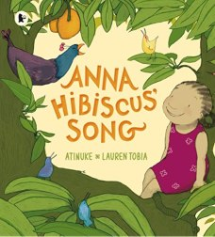
written by Atinuke and illustrated by Lauren Tobia
“This is the first picture book featuring Anna Hibiscus and she is very happy in it! So happy, in fact, that she can’t quite decide what to do with herself!! So she turns to her grandparents, her aunties, her cousins Chocolate, Angel and Benz, her uncle Tunde and her father, who each offer her a way to express her boundless joy. But being around the people she loves so much only makes her happiness grow and grow; she is SO happy, she is going to EXPLODE! “
- What makes Anna happy?
- What do her cousins do when they are happy?
- What does Anna’s uncle do when he is happy?
- What do you do when you are happy?
- How does Anna feel when she spends time with her family?
- Which songs make you feel happy? How does singing make you feel?

Resources

- Coronavirus, a book for Children
https://nosycrowcoronavirus.s3-eu-west-1.amazonaws.com/Coronavirus_ABookForChildren.pdf

- Mental health, bereavement and beating the virus. Coronavirus related free E-books for learners with learning disabilities, families and carers
https://booksbeyondwords.co.uk/coping-with-coronavirus/#MH-resources

- Happiness box. How to make a happiness box- step-by-step guide
https://www.evidenceforlearning.net/wp-content/uploads/2020/05/Rationale-for-the-Happiness-Box-Bev-Cockbill-Recovery-Curriculum-LearningShared-Ep-7.pdf

Bibliography

Carpenter Barry and Carpenter Matthew (2020) A recovery Curriculum: Loss and Life for our children and schools post pandemic. Published online: 23 May 2020
https://www.evidenceforlearning.net/recoverycurriculum/

Courtney Matthew (2020) 10 books to share as children return to school.
Published online: 20 May 2020
https://readteachlearnthink.wordpress.com/2020/05/20/10-books-to-share-as-children-return-to-school-after-lockdown/

Ducan Shaw and the “Recovery from Covid-19” team (2020) Recovering from Covid-19: the key issues, The University of Manchester, UK.
http://allianceforlearning.co.uk/wp-content/uploads/2020/05/recovering-from-covid-19-the-key-issues.pdf

Moore Chris (2020) Supporting post-lockdown education using the 6 principles of Nurture.
Published on: 5 May 2020, last updated: 18 August 2020
https://www.epinsight.com/post/supporting-post-lockdown-education-using-the-6-principles-of-nurture

RC PSYCH (Royal College of Psychiatrists) (2020) Psychiatrists reflect on kindness during Mental Health Awareness week. Published online: 19 May 2020
https://www.rcpsych.ac.uk/news-and-features/latest-news/detail/2020/05/19/psychiatrists-reflect-on-kindness-during-mental-health-awareness-week

UK Government (2020) Supporting wellbeing.
Published online: 5 May 2020, last update: 21 May 2020
https://www.gov.uk/guidance/supporting-pupils-wellbeing

Young Minds (2020) Coronavirus; the impact on young people with mental health needs.
www.youngminds.org.uk

